Shi-Min Wang
Associate Professor
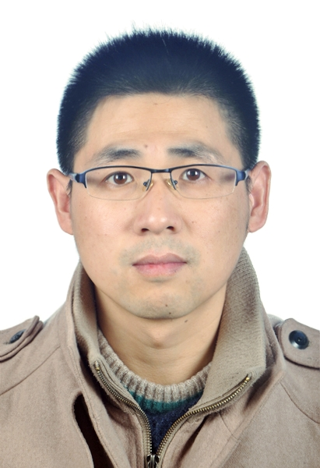
Department of Preventive Veterinary Medicine,
College of Veterinary Medicine,
Xinjiang Agricultural University,
No.311 East Nongda Road, Shayibake District,
Urumqi, Xinjiang 830052, People’s Republic of China.
PERSONAL INFORMATION:
Name:Shi-Min Wang
Nationality: The People’s Republic of China
Date of Birth: Aug 1986
Email: smwang@xjau.edu.cn
EDUCATION:
◆September 2018 ~ Present (June 2022) PhD candidate in Preventive Veterinary Medicine
Dept. of Preventive Veterinary Medicine, College of Veterinary Medicine, China Agricultural University.
◆September 2009 ~ June 2012 Master of Preventive Veterinary Medicine
Dept. of Preventive Veterinary Medicine, College of Veterinary Medicine, Xinjiang Agricultural University.
◆September 2005 ~ June 2009 Bachelor of Animal and Plant Quarantine
Dept. of Veterinary Medicine, College of Animal Science and Technology, Hebei North University.
RESEARCH FIELDS:
- Virus replication and assembly;
- New vaccine.
FUNDING
- Project from National Natural Science Foundation of China(NSFC), “Molecular mechanism for the retention function of envelope gD encoded by equine herpesvirus type 1 (31860710)”. (2019-2022)
- Project from Xinjiang Uygur Autonomous Region Natural Fund, “Study on Golgi-retention signal of EHV-1 gD and localization characteristic of different functional domains (2018D01B17)”.(2018-2021)

